Wagga Wagga Intramaps

- Modules

- Layers/ Legend

- Searching

- Information

- Tools

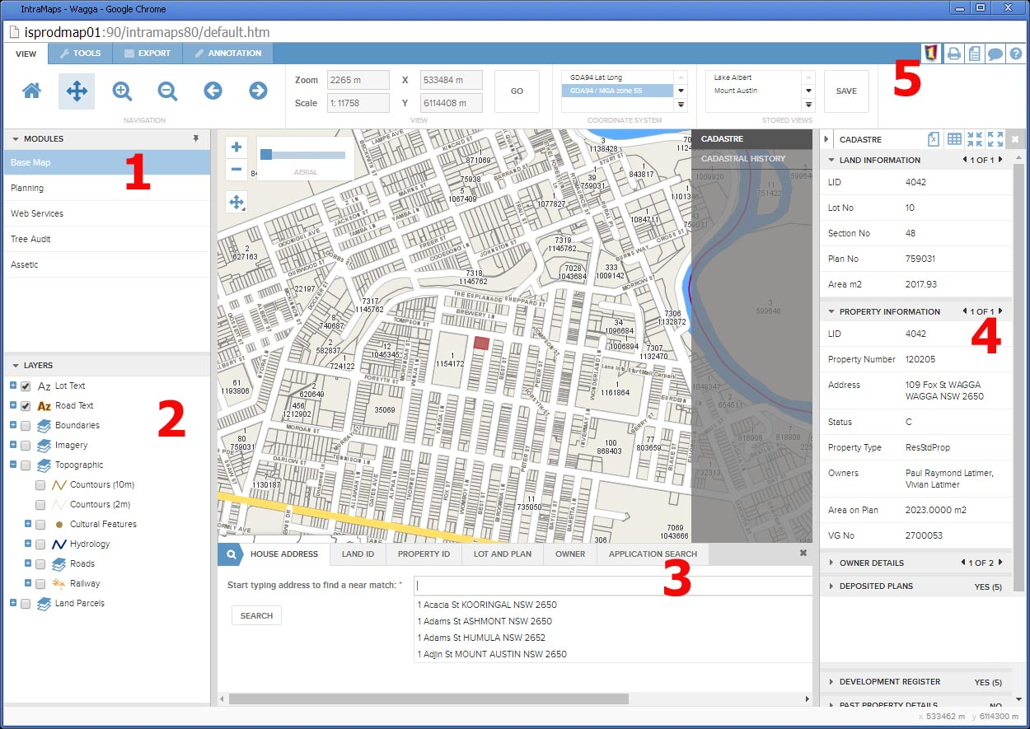

- Modules

Modules are preconfigured maps designed for a particular audience. Generally Basemap and Planning are available to all external users.

Intramaps will open in Basemap and you can switch between modules at any time. Any current selections will carry across to the new module if that layer exists in the new module.

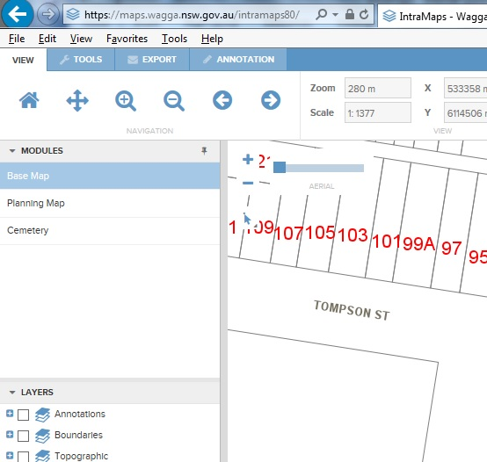

- Layers/ Legend

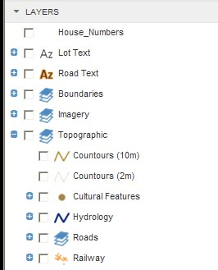
This area is a contents list of all layers available in the map. Click on the blue + to expand the categories and show the individual layers.

Tick or untick the box next to a layer to turn it on or off in the map. This will also remove the layer from any print layout templates.

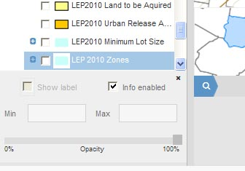
Click on the layer title to enable the layer control dialogue box. This will appear at the bottom left of the screen. Users can change the Opacity (transparency), the visible zoom widths, as well as whether or not information will return when features within the layer are clicked.

- Searching

The search panel is located below the map across the middle of the screen. Clicking on any of the search tabs will reveal the search forms. You can use the drop down boxes, or type directly into them with the search parameters. Hitting Enter or the search button will take you to the desired feature (if it exists).

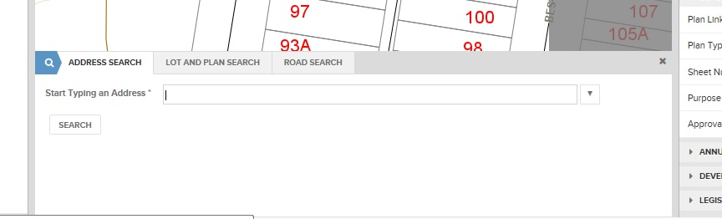

The available searches include:
- Address Search
- Lot and Plan Search
- Road Search

- Information

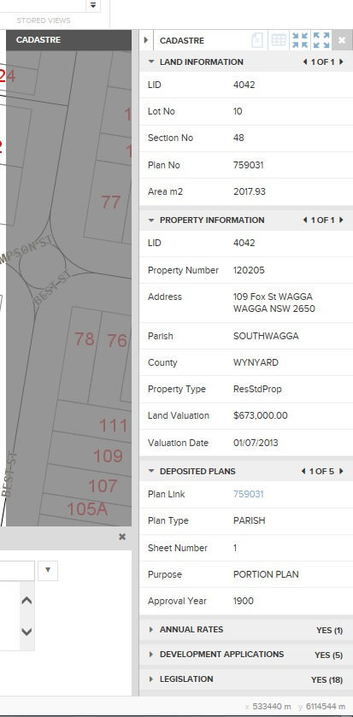
The information panel at right of screen displays available data for the selected feature(s). Information is grouped into various grey header boxes down the panel. These can be expanded or collapsed by clicking the arrow to the left of the header panel name. Land and property information boxes are expanded by default.

The grey layers panel to the left of the information panel shows how many and which layers are involved in the selection. When searching for house address etc only the Cadastre will be returned. If selecting directly from the map using selection tools eg: Circle or Polygon, any layer switched on in the map will be selected. These layers will then be displayed in the layers panel and you can switch between results for each layer.

Land and property information is being sourced from Council’s Rates system. Other data available for the selection is included below eg: Deposited Plans.
To the right of the name in the header panel is the number of records returned in the selection. You can scroll through each record by clicking the forward or back arrows.

Blue text indicates a hyperlink may be available to the document or web page associated with the result (eg: Deposited Plans).

- Tools

There are four tabbed control panels called:

- View
- Tools
- Export
- Annotation

View

The view tab contains all the navigation tools to pan and zoom around the map.
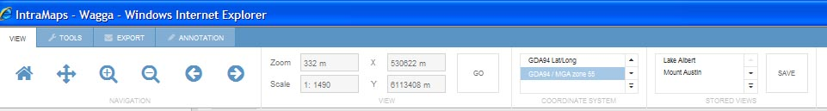

Home: Returns the user to predefined extents.
Pan: Allows users to move around the map. You do not need to specifically select this tool as simply clicking and dragging (without any tools activated) will pan the map around.
Zoom In: Allows users to zoom in to the area clicked or a rectangle is drawn.
Zoom Out: Allows users to zoom out from the area clicked or a rectangle is drawn.
Scrolling up or down on the mouse wheel when hovering over the map window will also zoom in and out also.
Previous View: Allows users to trace back through the previous zoom/pan levels.
Forward View: If a user has used the previous view button, this view moves forward from the previous views.
Location Information: Shows users the current zoom/scale of the map window as well as the Coordinates of the centre of the window.
Coordinate System: Allows users to change from GDA94 to Latitude/Longitude.
Stored Views: Allows users to save certain map locations for ease of access in the future.

Tools

This toolbar contains the various tools to select information from GIS layers. It also contains measurement tools for lines and areas.
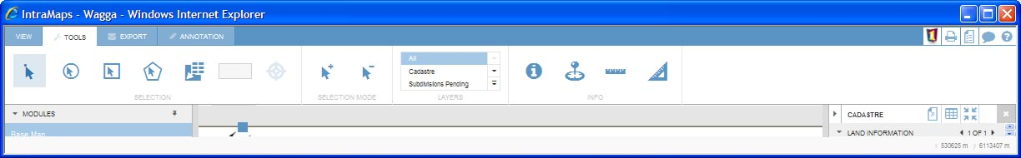

Point Selection: Allows you to click on features within the map window to produce the information panel about the feature.
Circle Selection: This tool is used to select objects that fall within a circle, drawn by the user. The radius of the circle is displayed in the status bar at the bottom right of the screen.
Rectangle Selection: This tool is used to select objects that fall within a rectangle drawn by the user. The height and width of the rectangle is displayed in the status bar at the bottom right hand side of the screen.
Polygon Selection: This tool is used to select objects that fall within a free-form shape drawn by the user. Double clicking the mouse will finish the shape.
Share Boundary Selection: Allows you to click on a feature and retrieve results for that feature as well as any other features on that layer that share a boundary (i.e. neighbours).
Add to or Remove from Selection: Allows you to add or remove particular features from the current selection. Clicking the plus will allow you to add features to the current selection while clicking the minus will allow you to remove features from the current selection.
Selection Layer Option: Allows you to isolate which layers you are trying to select when clicking in the map window. By default it is set to all, so it will return results from every layer that is beneath the clicked point. Setting it to property for example, will isolate the request to just the property layer.
If the option is set to ‘All’ (the default option) and the clicked portion of the map window has more than one layer with information, the information panel will show the grey slide out so users can choose which layer they want to view information from.
Information: Allows you to ‘quick query’ a particular area of the map. The results appear in a pop up window. You should note that results generated by this tool are taken from the physical map layers and are not necessarily as up to date as the results returned by the point selection tool referenced above.
Coordinate Capture: Allows you to click a particular area of the map window to generate a pop up display that tells the exact coordinates of that point.
Measure Distance: Enables you to manually measure the distance between chosen points. Double clicking after completion will produce a table that lists the various measurements taken. The total distance is shown at the bottom of the table window. You can also change the reported units in this window (feet, km etc).
Measure Area: Enables you to manually measure the area within a shape drawn. Double clicking after completion will produce a table that lists the various lengths of each side of the drawn shape. The total area is shown at the bottom of the table window. Users can also change the reported units in this window (hectares, yards2 etc).
GPS Location: Enables you (when on a mobile) to automatically snap the map to their current position. This does not work from desktop machines as no GPS unit is installed.

Export

These tools allow printing of maps, export to pdf or export to Excel or Word.
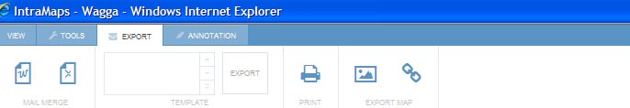

Mail Merge: These buttons allow you to export the selected feature(s) to a Word or Excel document for mail merging. The word document contains the name and addresses of the features as well as a map centred over the feature (property) whilst the excel document is simply a list that can be used to generate a Microsoft Office mail merge.
Template Selection: Upon selecting one of the above options, you will be prompted to select which template you would like produced.
Print: This allows you to produce a pdf or png image containing the map shown in the map window for printing.
Print Settings: Once you click the above ‘print’ button. This window will appear. You can select from the list of templates - deciding between A4, A3, Landscape, Portrait.
You can also decide if you want the map produced in a png or pdf. Titles can be typed into the “title” box and the scale can also be modified.
You will notice a blue window hovering over the map; this represents the area that will be printed by the selected template.
Ignore the print format options (raster/vector) leave as raster.
Export Map as Image: Allows you to export the map window as a pdf or picture file.
Export Link to Map: This allows you to send the current map window as a link to other users. When opening the link, the recipients IntraMaps session will be taken to that view.

Annotation

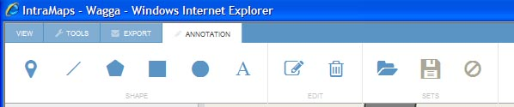

Symbol: Allows you to place a symbol/point on the map.
Line: Allows you to draw a line on the map. Double clicking completes the feature.
Polygon: Allows you to draw a polygon. Double clicking completes the feature.
Rectangle: Allows you to draw a rectangle/square.
Circle: Allows you to draw a circle on the map.
Text: Allows you to add text to the map.
Style Panel: After selecting one of the above annotation options, the style panel will appear for the desired option. Always set your style before adding the feature to the map. Text objects need to be typed in the text window before placing on the map.
Edit: Allows you to edit an annotation feature that they have already drawn. Click the edit button and then select the feature you wish to edit. The style panel also appears on the right so users can change the appearance of the annotation.
Delete: Allows you to delete particular annotation features. Click delete and then select the feature that you wish to remove.
Save: Allows you to save the annotations you have created for later use. This is convenient if you have just marked up a map pointing out various development opportunities. You may want to revisit the mark-ups at a future date. These annotations save against your login.
Open: Allows you to open previously saved annotations.
Annotation Load: Once you have selected the open button above, the list of available annotation sets will appear. Clicking on the annotation will load it, clicking the black ‘x’ will delete the annotation for good.
Clear: Deletes all annotations from the map window.

